Supply Order Form
Enter quantities for the supplies you need, then email or fax the completed form.

Clinic and shipping information
Clinic name _____________________________________ Account # __________________
Ordered by ______________________________________ Order date _________________
Phone __________________________ Email ______________________________________
Ship to address ______________________________________________________________
City __________________________________ State __________ ZIP ________________

Supplies requested
For items sold by the dozen, enter the number of dozens (1 = 12 items).
Qty | Supply item | Order unit
 | Submission forms* | —
 | Mini Tip Culturettes | Dozen
 | Regular Tip Culturettes* | Dozen
 | Anaerobic Culturettes | Dozen
 | Serum Transport Tubes* | —
 | Green Top Separator Tubes | Dozen
 | Hematocrit Tubes* (larger, heparinized / red banded) | —
 | Glass Coverslips* | —
 | Fecal Trichrome Tubes* (green bullets with safe fixative) | —
 | Sample Bags* (zip-top) | —
 | Plastic Slide Boxes* | —
 | Calorad | 16 oz bottle
 | Agrisept | 1 oz bottle
 | FedEx Clinical Packs* (outer shipping overwrap with government info) | —
* No charge to hospital. A dash indicates that no package size is specified.
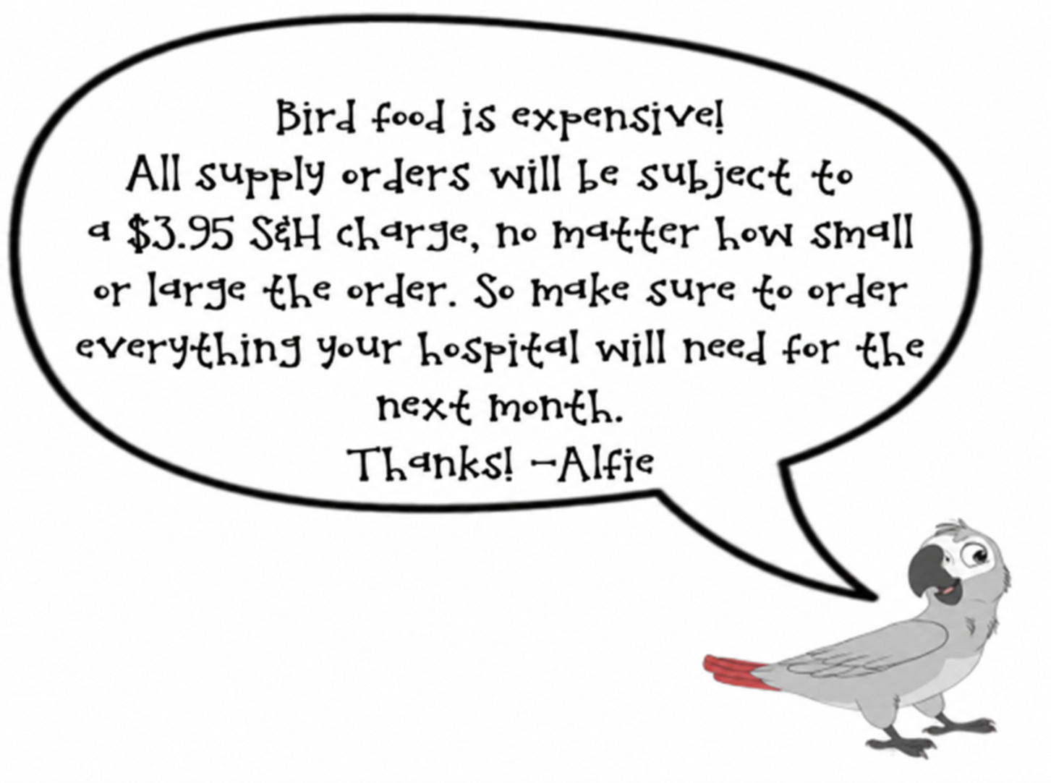
Notes _____________________________
__________________________________
__________________________________

Return your completed order
Email office@avianexoticlab.com
Fax 937-383-7773
Questions 800-350-1122
937-383-3347
avianexoticlab.com

